**Part B – Neural Activity Related to Choice**

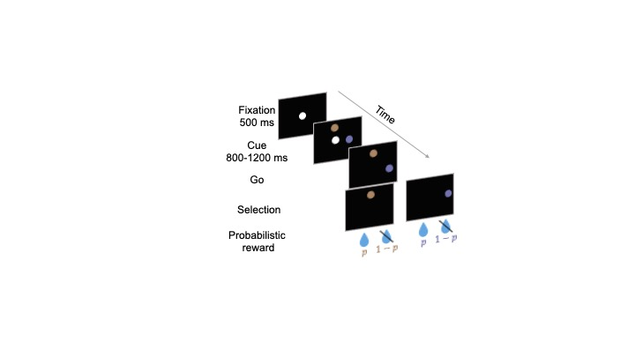**Task description:**

The monkey initially fixates on a central target. Then, two additional targets appear above and to the right of the central target. The colors of the targets indicate the probability of receiving a reward (a drop of baby food) if that target is selected. At this point, the monkey is required to fixate on the central white target and is not allowed to move its eyes to the colored targets. After more than 800 ms, the central target disappears, serving as a go signal for the monkey to select a target by moving its eyes to one of the colored targets. After making a selection, the monkey receives a reward with a probability determined by the color of the chosen target.

We used five different reward probabilities (0%, 25%, 50%, 75%, and 100%) and presented trials with all combinations, excluding the condition in which the two targets had the same probability (resulting in a total of 20 conditions). Trials from these conditions were randomly interleaved.

The directory ‘Data’ contains data from three neurons recorded from the substantia nigra pars reticulata—an output structure of the basal ganglia—during the task described above. We aim to understand what information these neurons provide when the monkey prepares to select a target. **Choose one neuron for questions 1–5**, and use **all three neurons for question 6.**

**Data structure – MATLAB/Python:**

The data is taken from the time the monkey was fixating on the central target and the two-color targets appear.

Please choose the data files from the MATLAB/Python Data folder, according to your choice.

MATLAB: It is organized in a table in which each row represents one of the task conditions.

The columns are ordered as follows:

Column 1: R_prob - the reward probability associated with the right target.

Column 2: U_prob - the reward probability associated with the upper target.

Column 3: choice - an array of strings of size T, where T is the number of trials. The string indicates which target was selected (RIGHT/UP).

Column 4: spikes - a matrix of size T X 800, where T is the number of trials and 800 is the time in 1 ms resolution. The value in each entry is 1 when the neurons spiked at the specific trial at the specific time and 0 other ways. For example, if MAT(10, 500) ==1 then the neuron spiked in the 10th trial 500 ms after the color targets appeared.

Python: It is organized as a DataFrame in which each row represents one trial.

The columns are ordered as follows:

Column 1: R_prob - the reward probability associated with the right target.

Column 2: U_prob - the reward probability associated with the upper target.

Column 3: choice – Indication of which target was selected: 0=UP,1=RIGHT

Column 4: spikes – an array (800,) of zeros and ones. 800 is the time in 1 ms resolution. The value in each entry is 1 when the neurons spiked at the specific trial at the specific time and 0 other ways.

* For loading the ‘Python_Cxxxx.pkl’ file, please use the following:

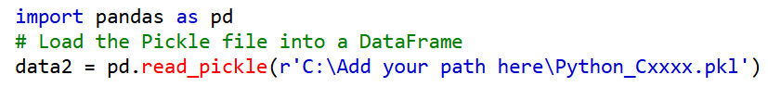

**Please submit graphs with a short explanation. Add titles, labels (e.g. firing rate, trial number, Time), and when relevant the units (e.g. spike/s, second, millisecond) to your plot's horizontal and vertical axis.**

**Questions:**

1. **Behavior analysis.** Calculate the number of trials in which the monkey selected the high-probability target. Use the table column corresponding to the choice to answer this question.
   1. What is the optimal behavior that will maximize the amount of reward in this task?
   2. How often did the monkey select the target associated with the higher probability? Is the behavior optimal/close to optimal?

**For simplicity, from this point, unless mentioned explicitly, we will assume the monkey selected only the trials with the higher probability.**

1. **Spike rasters.** Write a script that shows two raster plots, one in which you plot all the trials in which the high probability was RIGHT and another one for all the trials in which the high probability was UP. Examine the raster visually and answer the following questions:
   1. How much time (approximately) does it take the neuron to respond to the appearance of the color targets? How did you make this estimate.
   2. After the initial latency, is the response of the neuron constat or does it fluctuate in time? Explain your answer based on the visual examination of the raster.
   3. Does the neuron respond differently in trials that the large reward was UP and RIGHT. Explain your answer.
2. **Calculating PSTH.** For each task condition calculate the peri-stimulus time histogram (PSTH) by averaging the columns of each raster. Multiply the PSTH by 1000 to convert to units of spike/s. Plot one of the histograms then smooth the PSTH with a moving mean of 100 ms (matlab: smoothdata, python: uniform_filter1d from scipy.ndimage for example) and plot the smoothed PSTH on the same plot.
   1. Which of the PSTH seems to you more informative?
   2. What is the advantage/disadvantages of using the smoothed data.
3. **Examining PSTHs.** Plot the smoothed PSTHs for all task conditions in a single plot, use different colors for conditions that the high probability target is UP and RIGHT. Next, average all PSTH in which the high probability is RIGHT or UP separately and plot these two averages in another plot. Examine visually the plots and answer the following questions:
   1. Does the neuron respond differently to the different task conditions? Explain your answer.
   2. Does the neuron respond differently to conditions in which the high probability is UP and RIGHT. Explain your answer.
   3. Does the neurons respond differently within condition in which the high probability is UP or RIGHT. Explain your answer.
   4. Mention one property of the response of the neuron that was hard to notice in the raster (Q2) but clear in the PSTH.
4. **Quantitative analysis of the neuronal response.**

* For each condition, calculate the average number of spikes per Condition. This can be done either by first summing the spikes in each trial and then averaging across trials, or by averaging across trials (i.e., creating a PSTH) and then summing across time. Note that the units might differ slightly depending on how you perform the averaging (e.g., spikes/trial, spikes/s, spikes/ms). Ensure that you understand the units and include unit labels on all plots.
* Plot this average as a function of the high probability, plot in different colors condition in which the high probability is RIGHT or UP. For sanity check, the plot should contain 10 points in one color and 10 in another.
* Calculate the linear regression between the high probability and response separately for conditions in which the high probability is RIGHT or UP. Plot the regression line. Examine the plots and answer the following questions:
  1. Is the activity of the neuron modulated by the high probability? Does it increase of decrease rate as the high probability increase.
  2. Is the slope of the linear regression the same for the conditions in which the high probability is UP and RIGHT?
  3. Is the intercept of the linear regression the same for the conditions in the high probability is UP and RIGHT?
  4. **Based on the results does the neuron have information about which target was selected, the chosen value, or something else? Explain your answer.**

1. **Comparative analysis of the responses.** Repeat the analyses in Q5 for all three neurons and plot the graphs. What is the difference between neurons? Is the activity of the neuron related to the upcoming selection, the probability of the chosen value? Both? None?
2. **Bonus.** Is the activity of the neuron modulated by the target that was not selected? How did you check this?
3. **Exploration:** Examine visually again the neural responses of the neurons. Mention at least one property of the response that you find interesting but was not highlighted in the questions above. Explain your answer.

Good luck!

**Submission Guidelines:**

Submission due to: **18/1/2025**

* Submit all your answers and figures as one merged PDF file.
  + Please review the file and see if it’s readable
* The code should be submitted separately as an **executable** file (.m or .py).
  + Please document your code
* Indicate the number of the question and section at the beginning of each part of your answer.
* Submit all answers and figures in the order they appear in the exercise.
* Make sure you explain the results you got in all questions. Explain what you see in each figure.
* Make sure to indicate labels and units on the axes of the graphs.
* Answers may be given in English or Hebrew.